3. An irregular sample of 9 qualities from an ordinary populace demonstrated a mean of 41.5 inches and the entirety of square of deviation from this mean equivalent to 72 inches. Show whether the supposition of mean of 44.5 inches in the populace is reasonable.(For *v*=8, *t*.05=2.776)

[**https://www.tutorialspoint.com/statistics/student_t_test.htm**](https://www.tutorialspoint.com/statistics/student_t_test.htm)

**What is hypothesis Testing?**

Hypothesis testing is an educated guess to detect significant differences by comparing sample statistics with population parameters. Hypothesis testing is used to infer the result of a hypothesis performed on sample data from a larger population.

**Hypothesis testing** is used to confirm conclusion (or hypothesis) about the population parameter (which we know from EDA or your intuition). Through Hypothesis Testing, we can determine whether there is enough evidence to conclude that the hypothesis about the population parameter is true or not.

Hypothesis testing starts with the foumulation of these two hypothesis:

1. Null Hypothesis
2. Alternate Hypothesis

**Null Hypothesis?**

Null hypothesis is prevailing belief about the population.

It states that there is no change or no difference in the situation.

It said that status quo is true.

It always denoted by (H0). It always contains the ‘=’ sign. H0:u1=u2 [no difference between two population parameters]

If the difference between sample statistic is large enough assuming that H_0 is true, then we have to reject H_0 and conclude there is difference between the populations.

**Example**: Government regulatory bodies have specified that the maximum permissible amount of lead in any food product is **2.5 parts per million or 2.5 ppm**.

If we conduct tests on randomly chosen Maggi Noodles samples from the market, the null hypothesis in this case:

The average lead content is less than or equal to 2.5 ppm

The null hypothesis is the status quo, i.e. the average lead content is within the allowed limit of 2.5 ppm.

**Alternate Hypothesis**

It claims the oppose the null hypothesis.

Denoted by (H_a) or (H_1) which means there is significant difference and the difference is cause by some non-random chance.

H_1 always contradicts the H_0. It also said research hypothesis.

It always challenges the Status Quo.

H_1:u_1=/u_2

**Example**: Government regulatory bodies have specified that the maximum permissible amount of lead in any food product is **2.5 parts per million or 2.5 ppm**.

The alternate hypothesis in the same case, when we conduct tests on randomly chosen Maggi Noodles samples from the market:

The average lead content is more than 2.5 ppm.

The alternate hypothesis is the opposite of the null hypothesis. Since the null hypothesis is that the average lead content is less than or equal to 2.5 ppm, the alternate hypothesis would be that the average lead content is more than 2.5 ppm.

**Types of Errors**

In Hypothesis testing there are two types of error

1. Type-1 Error (a – alpha): A type-I error appears when the [null hypothesis](https://byjus.com/maths/null-hypothesis/) (H0) of an experiment is true, but still, it is rejected. It is stating something which is not present or a false hit. A type-I error is often called a false positive (an event that shows that a given condition is present when it is absent)

Example: The test results says that I have covid-19 but actually real case it is not true. That is type-1 error,

1. Type-2 Error (B – beta): A type II error appears when the null hypothesis is false but mistakenly fails to be refused. It is losing to state what is present and a miss. A type II error is also known as false negative (where a real hit was rejected by the test and is observed as a miss).

Example: In another test result said that I don’t have Covid-19 but actually I have covid-19. In this case it called Type-2 error.

In [hypothesis testing](https://www.statistics.com/glossary/hypothesis-testing/), the test procedure partitions all the possible sample outcomes into two subsets (on the basis of whether the observed value of the test statistic is smaller than a threshold value or not). The subset that is considered to be consistent with the [null hypothesis](https://www.statistics.com/glossary/null-hypothesis/) is called the "acceptance region"; another subset is called the "rejection region" (or "critical region").

**What is the Z Test?**

z tests are a statistical way of testing a hypothesis when either:

* We know the population variance, or
* We do not know the population variance but our sample size is large n ≥ 30

*If we have a sample size of less than 30 and do not know the population variance, then we must use a t-test*

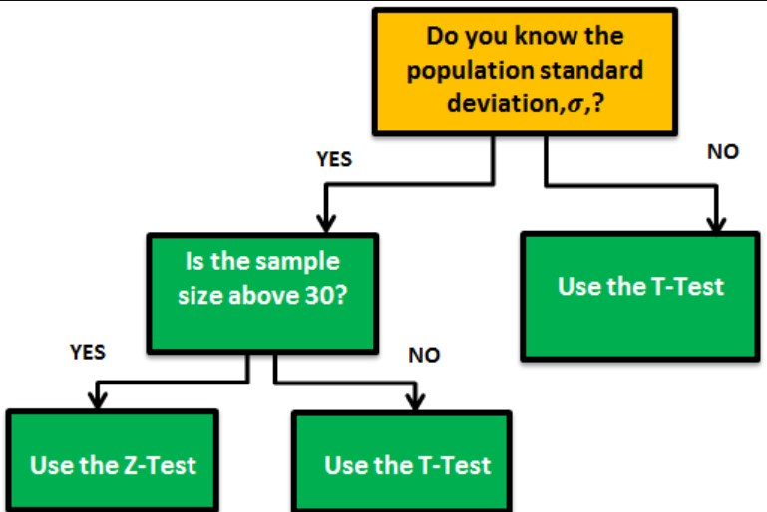



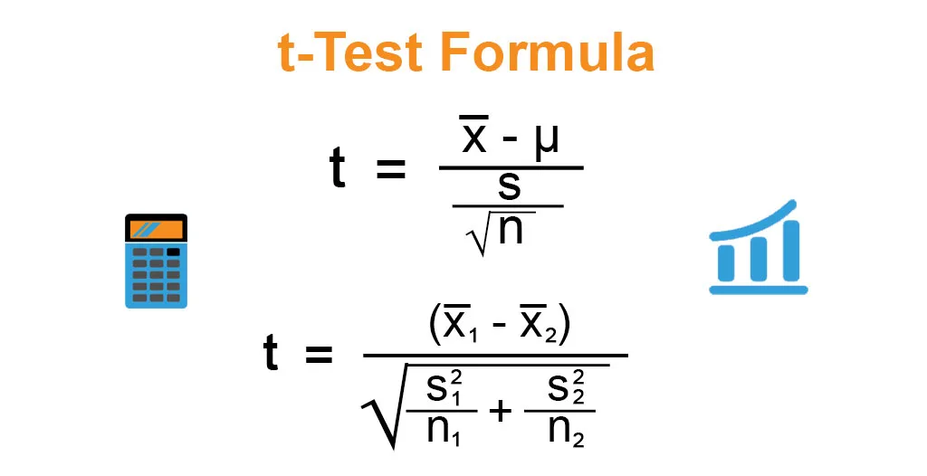

**Non-probability sampling** is a method of selecting units from a population using a subjective (i.e. non-random) method. Since non-probability sampling does not require a complete survey frame, it is a fast, easy and inexpensive way of obtaining data. However, in order to draw conclusions about the population from the sample, it must assume that the sample is representative of the population.

An example of convenience sampling would be using student volunteers known to the researcher. Researchers can send the [survey](https://www.questionpro.com/blog/surveys/) to students belonging to a particular school, college, or university, and act as a sample.